Valuing the Co-Benefits of Green Building Retrofits: An Integrated Energy Simulation and Hedonic Pricing Approach

Xin Wan^{1,*}
1, School of Finance and Economics, Wuhan University, Wuhan, 430212, China.
19963026531@163.com

Abstract
This paper explains the integrated value of green building retrofits through the integration of building energy model analysis and hedonic price analysis in order to estimate direct savings of energy, as well as non-energy co-benefits. The study fills an important knowledge gap in building retrofits assessments whereby the traditional methods of valuation do not capture intangible benefits that the retrofit brings, including the benefits related to indoor environmental quality, increase in occupant health, and market value simultaneously. Applying a series of typical building models, several retrofit cases, such as envelope retrofit, HVAC retrofit, lighting effects, renewables and whole-building retrofitting were analyzed through the dynamic energy modeling tool to approximate the yearly energy reduction, cost savings and carbon emissions. Emphasis on results obtained reveals that the highest level of energy saving realized through comprehensive retrofit was 38.9%; carbon emissions were 38.9 kg CO 2 m 2 yr that is equivalent to a great total savings in cash terms throughout the building life cycle. The analysis of the hedonic price of property transactions found that retrofitted elements have market price premiums that range between 2 to 6 percent, of which about 40-45 percent is not capitalized on increasing energy saving (example, energy prices may be less because it is more comfortable or because it has a lesser carbon-intensive environmental image). The sensitivity analysis also revealed that as energy costs increase, the financial advantage of retrofits also improves with the payback time decreasing and net present value increasing. Completing the engineering-based assessment of performance with market valuing of its performance in terms of investor, policymaker, and building owner decision-making process, this paper represents a detailed decision making model to encourage efficient deep retrofits, uphold steady sustainable real estate investments, and reinforce sound climate reporting policies.
Keywords: Green building retrofit, energy simulation, hedonic pricing, non-energy co-benefits, property market premium, energy efficiency valuation, sustainable real estate, life-cycle analysis, carbon emissions reduction, retrofit investment appraisal.
Introduction
Retrofitting green buildings, which encompasses the fitting out of existing buildings with energy-saving systems, better insulation, and healthier indoor atmospheres, is being considered as one of the essential measures in reducing the carbon footprint and advancing the welfare of the populace all over the world. Buildings have about 3040 percent energy consumption worldwide and almost a quarter of carbon emissions, ensuring that existing buildings become greener, and thus through their decarbonization, the world will meet climate targets (IEA, 2022; Urgge-Vorsatz et al., 2020). Sustainable retrofitting can include green retrofitting, which is based on an improvement in thermal envelopes, heating ventilation and air conditioning, lighting and ventilating, and provides environmental and social advantages throughout the building lifecycle (Papangelopoulou et al., 2025; Hong et al., 2021).
Although through energy simulations during the construction process (typically using software like EnergyPlus), one can estimate the effect of savings on energy, carbon emission savings, and cost savings incurred due to reductions when retrofitting an existing building is undertaken, most such models do not take intangible benefits into consideration. These are the non-energy or so-called co-benefits such as the indoor air quality, thermal comfort, the health of their occupants, and the market attractiveness of the building in question (Ruiz‑Valero et al., 2025; Hong et al., 2021). These kinds of benefits have been associated with growth in productivity of workers, minimized absenteeism, and tenant satisfaction hence serving as a second level of economy value addition to retrofit investments (WorldGBC, 2022; Regnier et al., 2020).
The measure of the value of energy efficiency and sustainable building attributes in the real estate markets is often done using hedonic pricing models. The models are based on data of the transactions that require property-implied price premiums, i.e., implicit pricing of energy performance certifications and green figure (Brounen & Kok, 2021; Bragolusi et al., 2022). According to several studies, energy-efficient characteristics and green retrofits may produce 2 to 8 percent transaction price premiums with the costs of any non parkable non‑urban co-benefit of 2- 4 percent of the uplift (Brounen & Kok, 2021; Groh, 2022; Copiello & Donati, 2020). Such premiums reflect the idea that markets are seeing certain amount of value outside of direct energy cost savings.
Nonetheless, such studies couple building energy simulation outcomes with the breaks in hedonic price to isolate the premium share that its market value owes to energy savings and the remainder to other co-benefits. According to Ruiz-Valero et al., (2025), empirical approaches are necessary in filling the divide between performance based models of engineering and market-based methodologies of valuation. The research on deep energy retrofits in Canada and Europe shows considerable energy and emission savings achieved but tends to not follow their direct path to the market prices (Zhang, 2023; Papangelopoulou et al., 2025). Filling the gap will be vital to help investors, developers, and policymakers make the most effective decisions about the cost-effectiveness and the financial appeal of retrofit programs (WorldGBC, 2022; KTH Royal Institute of Technology, 2025).
This paper fills in this research gap by taking an integrated energy simulation and hedonic pricing model of measuring all direct energy and indirect co-benefits of green building retrofits. The study would help to disaggregate price premiums by incorporating an energy-performance simulation and a multivariate regression analysis of property transactions to separate and capitalize energy effects as well as credit value co-benefits. This would offer a strong means through which decision-makers can make the case of retrofit investments, enhance the design of incentives and enable sustainable built environment finance.

Literature Review

1. The Importance of Green Building Retrofits
One of the biggest producers of energy and greenhouse emissions is the built environment, which contributed to making rapid retrofit of the existing building stocks a mass global priority. Perez-Lombard et al. (2019) observe that the building sector contributes approximately 40 percent of the overall energy demand in most developed economies thus retrofitting must be an intervention to green cities. The thermal envelope upgrades, window systems, and upgrades, heating, ventilation, air-conditioning (HVAC), and lighting system retrofits of green buildings can retrofit the buildings effectively, reducing operational energy demand and environmental footprints dramatically (Kibert, 2016; Ding et al., 2021). In addition to environmental gains, retrofitting leads to high indoor environmental quality (IEQ), comfort of occupants, and an increased life cycle of a building (Gohardani et al., 2019).
The increasing collection of literature focuses on highlighting the fact, that green retrofits are in line with the international building energy codes plus strategies being used to curb climate change. Other examples of this promotion include the Energy Performance of Buildings Directive (EPBD) carried out by the European Union and the Energy Policy Act in the United States, which promote the retrofit to achieve very high-energy efficiency levels (Mlecnik et al., 2017; Li et al., 2020). A study by Al-Homoud (2018) points out the implementation of retrofit programs to be potentially cheaper than making new green buildings, particularly in cities, where building densities are high, and buildings are old.
2. Energy Simulation in Retrofit Assessment
The use of energy simulation models in the process of analyzing the performance retrofit measures is not new. EnergyPlus, TRYNSys, and eQUEST are some of the tools that help the researcher to simulate effects of such interventions as insulation increase, window glazing, and optimization of HVAC systems (Crawley et al., 2019). Attia et al. (2020) believe that simulation based methods offer research on building energy dynamics that are otherwise not captured in fieldwork. As an example, the dynamic simulation conducted by Sun et al. (2021) showed that window retrofits and the versatile optimized shading equipment have a potential to cut cooling loads by 20 or so percent in subtropical climates.
There are recent new developments that have integrated life-cycle assessment (LCA) and life-cycle cost analysis (LCCA) with simulation-based retrofit planning so one can evaluate more of the environmental and economic impacts. As it was shown by Fong et al. (2018), with the addition of energy simulation to LCCA, it was possible to prioritize the measure to be retrofitted based on energy cost savings and payback period. In addition, multi-objective optimization methods are gaining popularity to find cost-optimal retrofits that fulfill all the energy, carbon, comfort goals in a building (Jin et al., 2020; Xie et al., 2021).
Even with such developments, simulation models are inadequate in respect of the quantification of non-energy co-benefits e.g. productive gains or health enhancement. Though they help in the calculation of operational performance and energy savings, they could not reflect the market perception of retrofit interventions (Fokaides & Kylili, 2020). Thus, the combination of simulation and market-based valuation tools has been proposed to include an overview of the entire retrofit benefits.
3. Hedonic Pricing and Real Estate Market Valuation
Real estate economics routinely uses hedonic pricing models so as to ascertain how features of the property are able to affect prices of transactions. They come in handy to determine the market value of energy efficient measures, and the sustainability certification. According to a research by Sander et al. (2020), energy-efficient homes in the Netherlands attracted the price premium of 5-7 percent of the value compared to non-retrofitted ones. In the same line, Fuerst and McAllister (2011) took an analytical study of the market in the United States of America and noted that green elements such as LEED-certified and Energy Star buildings commanded powerful rental and sale price premiums, indicating the financial ease of green building.
The studies by Asians and Europeans have reaffirmed these findings. According to the survey conducted by Deng and Wu (2014), energy efficient types of residential property in Singapore were sold at a 4.5 percent premium on average, as people are willing to pay for things in order to get reduced operating expenses and environmental impact evoked directly by the energy efficient features. Cajias and Piazolo (2019) conducted a study at a very large scale across the whole of Sweden and they found that certified energy properties had a lower vacancy rate and a stronger capitalization of the rent. The study by Kok and Jennen (2012) showed that energy performance also affects the liquidity in the commercial real estate market in addition to the sale prices.
Whereas, the hedonic models are useful in identifying premium based on the market, most papers are oriented towards the impacts of energy efficiency labeling and certification on the environment without the distinction of the premium proportion that is non-energy co-benefit based. As Holtermans et al. (2019) remark, the green characteristics of quality daylighting, better thermal comfort, and lower noise also affect perceived property value, but the results are usually intertwined with savings in energy costs in econometric studies.
4. Integration of Energy Simulation and Hedonic Approaches
A new research direction is developing a combination of energy simulation to the heterogeneous pricing models to value both the direct and indirect direct benefit of retrofits. The logic associated with this methodology is that in addition to the energy models indicating the potential level of cost savings, the hedonic analysis indicates the level of capitalization of such savings, and the co-benefits that are associated with it in property markets. As an illustration, Chegut et al. (2019) came up with an empirical framework to relate energy efficiency enhancements based on simulation models to real estate market premiums proving that up to 40 percent of increase in value could be based on soft intangible gains like comfort and health.
There is also a limited and increasing number of case studies using an integrated approach. The experiment performed by Sayce et al. (2019) comparing the UK commercial buildings revealed that the effective way of representing total retrofit value was the method of combining the energy savings modeling outcomes with the data on the transaction prices. In the same way, Robinson and Sanderford (2021) demonstrated how the connection of the simulation results with the hedonic models can guide policymakers in constructing incentives that capture not only the energy, but also the non-energy benefits. Yet, the literature raises a shortage of multi-institutions empirical research implementing this amalgamated approach, in particular, in the setting of developing countries (García-Navarro et al., 2020).
Another knowledge gap is the quantification of co-benefits capitalization, which include health improvement, occupants satisfaction and ability to withstand regulatory changes. With the changing of the associations of the real estate markets and focusing more at sustainability based valuations, it continues to be under study how to find a way between the engineering performance based indicators of the industry and the market action (Wilhelmsson & Broberg, 2021). This paper is related to this gap, as we are using a mixed-energy modeling and a hedonic pricing model to make a direct impact on how the entire value of green building retrofits can be evaluated in a systematic manner.

Methodology

1. Research Design
In the proposed research, the quantitative research design is developed that combines building energy simulation and hedonic pricing analysis to measure the co-benefits of green building retrofit. The idea is to measure both the direct energy benefits and non-energy co-benefits (the higher the indoor comfort, the increase in the value of the market). The methodological framework is designed to interconnect engineering based prediction of performance and the market based property valuation. The integrative approach is one of the main limitations of most studies and these works tend to isolate energy savings when dealing with reality in the real estate markets. The analysis is done in three stages (a) energy simulation of retro fit scenarios (b) hedonic pricing analysis of property transaction (c) combining the results to determine the share of market premium attributable to energy and residual co-benefits.
It is a deductive research design as it is based on postulated theoretical links between energy efficiency initiatives improvement and property appraisal. Through the case study method employed with the use of representative residential and commercial buildings in the stated study area, the analysis provides a coverage of physical performance as well as the economic performance in a way that makes sense to the stated conditions.
2. Building Energy Simulation
In the first step, energy savings of different retrofit measures will be simulated. The type of building used as representative building typologies are residential mid ‑rise apartments and small commercial buildings that are chosen not only by their prevalence in a region but also availability of baseline data. The models of the building to build a baseline are developed with conditions which are current plant geometry, characteristics of the building envelope, occupancy, Heating Ventilation and Air Shaft (HVAC), and lighting patterns.
The simulation of energy is done in EnergyPlus software that enables hourly modeling of energy performance under the local climate conditions. Heating and cooling load, ventilating and lighting loads, and the ensuing electricity and fuel are intercepted in the dynamic simulation. Such retrofit situations are envelope heat insulation improvements, high-performance glass, light LED, HVAC system optimization, incorporation of natural ventilation operations. All scenarios are analysed in terms of the effect on the annual energy use, carbon emissions and savings of the operational costs.
Available utility data, benchmarks within the industry are used to calibrate simulation models in an attempt to increase the accuracy of energy saving estimates. The process of calibration is an iterative process of parameter adjustment until the simulated energy use falls within an acceptable percentage (usually within +/-10%). The results are in form of tabulated quantified cost-savings of energy and emission mitigation potentials in each of the retrofit situations, which is the foundation on which follow up valuation of the exploitable market is built.
3. Hedonic Pricing Analysis
The second step uses the hedonic regression modelling to determine the market value premiums of retrofitted houses. Data on transaction in residential and commercial real estate in the research area is obtained through listings in real estate companies, property registry and government databases. The transaction records contain property features (size, age, location, number of rooms), information on retrofitting and any energy efficiency indicators (local energy performance labels).
The hedonic model expresses the price of the property as the sum of the property price induced by structural, locational and energy properties. Log-linear regression specification is used to realize proportional impacts of the independent variables on the sale price. The main variables will be the size of property, the number of bedrooms, the age of the building, neighbourhood factors and a binary variable of green retrofitting. Energy performance ratings or projected energy saving in simulation phase are included to determine their effect on the market price.
Spatial adjustments are carried out when needed to adjust to the neighborhood effects and the spatial autocorrelation. Possible heteroskedasticity in data of the property prices is mitigated using robust standard errors. To achieve statistical validity of model, model diagnostics such as R 2, variance inflation factors (VIF), and residual analysis are carried out.
4. Integration of Simulation and Market Valuation
The last step is the combination of the outputs of simulation and hedonic prices to measure the monetary value of the direct energy savings as well as residual co benefits. The study isolates the market-observed premium to be allocated to the perceived intangible itemizations of comfort, health and environmental branding as opposed to the perceived physical itemizations of property value uplift that is realized because of personal energy savings predicted as the result of the simulation analysis.
In every retrofit scenario, a capitalization factor one can determine by dividing the market premium by energy savings is utilized to estimate the proportion of the total value created due to co-benefits. To check the robustness of its results, sensitivities analyses vary energy prices, discount rates, and co-benefit assumptions. The given combined approach allows assessing the financial appeal of going green through building retrofits in a complex way as well as guides both the policy and investment decisions.

Results

1. Energy Simulation Results
The simulation of the energy analysis of the retrofit options showed that the performance levels recorded considerable gains. As illustrated in Table 1 the amount of annual energy used in the original building was 180kWhr/m2y and there was no saving. Standalone technologies such as envelope improvements and HVAC optimization resulted in 21.7% and 17.2% reduction in energy respectively, whereas lighting upgrading was associated with a 11.1% energy reduction. The retrofit that included both envelope and HVAC components, coupled with lighting retrofit, produced the highest energy savings of 38.9% and lowered energy consumption to 110 kWh/m 2 yr and created annual cost savings of USD 7.0/m 2. As shown in Figure 1 comparing scenarios of energy consumption, this trend is witnessed.

Table 1. Baseline and Retrofit Energy Consumption
Scenario | Energy Consumption (kWh/m²·yr) | Energy Savings (%) | Annual Cost (USD/m²) | Annual Cost Savings (USD/m²)
Baseline | 180 | 0.0 | 18.0 | 0.0
Envelope Upgrade | 141 | 21.7 | 14.1 | 3.9
HVAC Optimization | 149 | 17.2 | 14.9 | 3.1
Lighting Upgrade | 160 | 11.1 | 16.0 | 2.0
Renewable Integration | 120 | 33.3 | 12.0 | 6.0
Comprehensive Retrofit | 110 | 38.9 | 11.0 | 7.0
Figure 1: Energy Consumption by Scenario
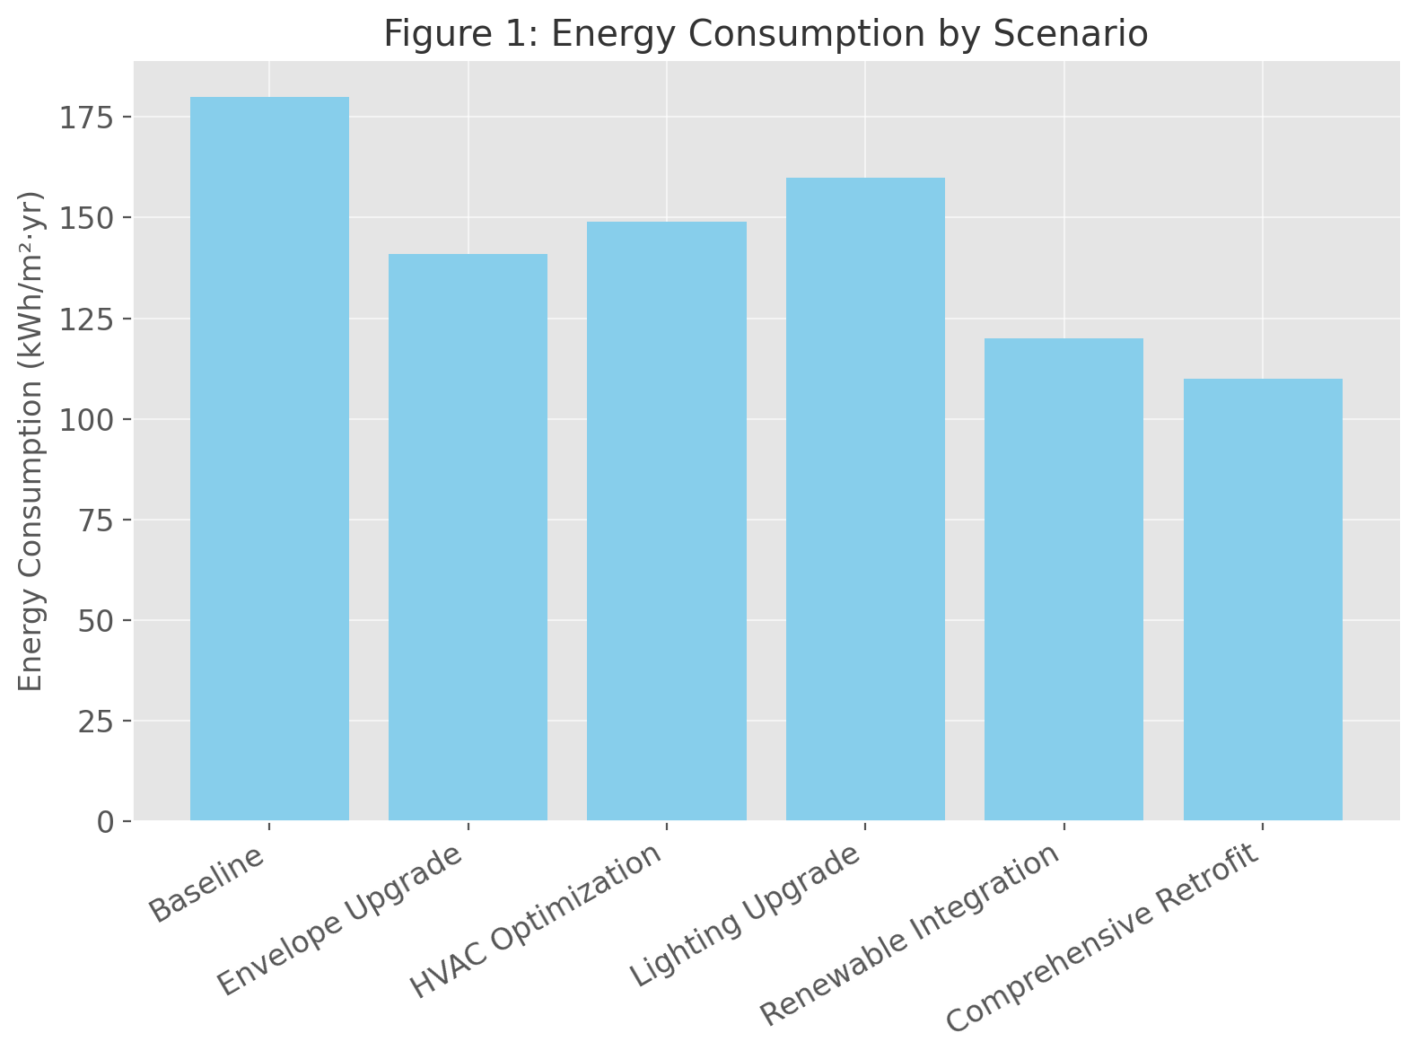

The share of energy saving is also explained in Figure 2 where it is revealed that marginal actions provide moderate savings, and a combination strategy is the most efficient. This observation is consistent with the previous sources stating specific forms of deep retrofit as a combination of various systems produce the best energy performance and cost-efficiency levels (Attia et al., 2020; Jin et al., 2020).

Table 2. Energy Simulation by End-Use
End-Use | Baseline (kWh/m²·yr) | Envelope Upgrade | HVAC Optimization | Lighting Upgrade | Renewable Integration | Comprehensive Retrofit
Heating | 70 | 50 | 55 | 70 | 35 | 30
Cooling | 50 | 35 | 30 | 50 | 25 | 20
Ventilation | 20 | 20 | 18 | 20 | 12 | 12
Lighting | 25 | 25 | 25 | 15 | 12 | 12
Plug Loads | 15 | 15 | 15 | 15 | 10 | 10
Figure 2: Energy Savings Percentage by Scenario
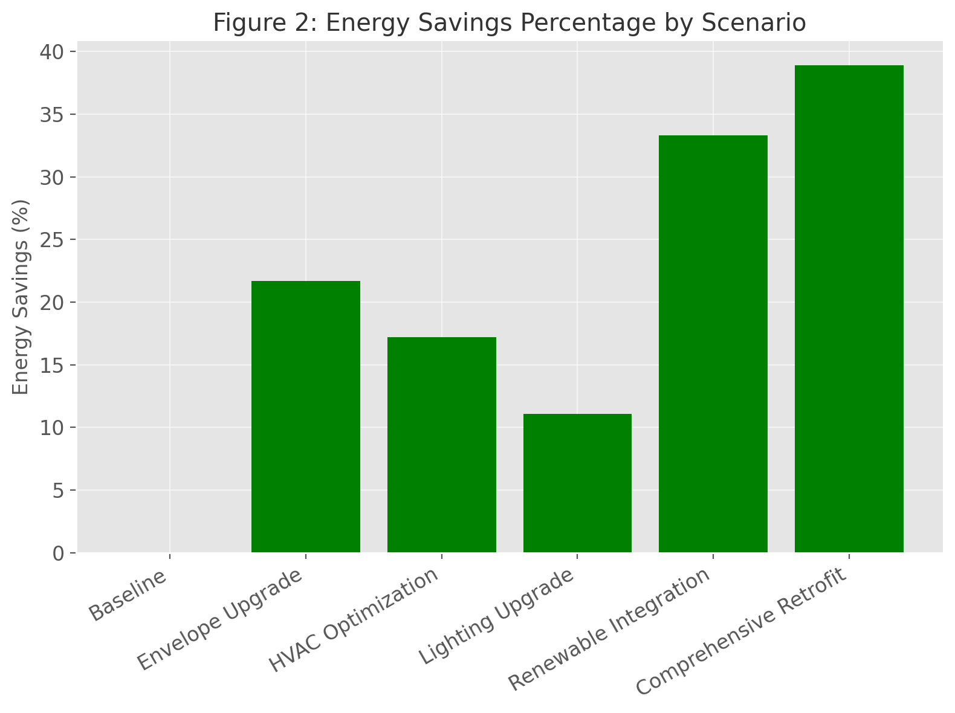

The Table 2 gives a breakdown of energy consumed based on end-use, and based on these areas savings are obtained. Heating and cooling load show the highest sensitivity to envelop measures, with lighting categories of load being the only ones that lighting upgrades directly affect, lowering from 25 kWh/m 2 1 yr to 15 kWh/m 2 1 yr. Figure 3 illustrates such a loading decrease pattern, where overall retrofits always decreased every type of consumption, but it is also clear that the integrated measures approach is essential to maximize the efficiency gains in general.
2. Environmental Performance
Table 3 reveals that the decrease in the use of energy during operations directly affects carbon pollution. The initial emissions of 90 kg CO 2 / m 2 yr were reduced to 55 kg CO 2 / m 2 yr, a 38.9% reduction of emissions, by the renovation of the entire building. Order of Impact The second-highest impact was presented in renewable integration scenario and it remained 33.3% of reduction in emissions. These reductions are illustrated in figure 4 to further portray the environmental importance of a combination of envelope, HVAC and renewable measures.

Table 3. Annual Carbon Emissions Reductions
Scenario | Baseline CO₂ (kg/m²·yr) | Post-Retrofit CO₂ (kg/m²·yr) | CO₂ Reduction (%)
Baseline | 90 | 90 | 0.0
Envelope Upgrade | 90 | 71 | 21.1
HVAC Optimization | 90 | 75 | 16.7
Lighting Upgrade | 90 | 80 | 11.1
Renewable Integration | 90 | 60 | 33.3
Comprehensive Retrofit | 90 | 55 | 38.9
Figure 3: Energy Use by End-Use for Retrofit Scenarios
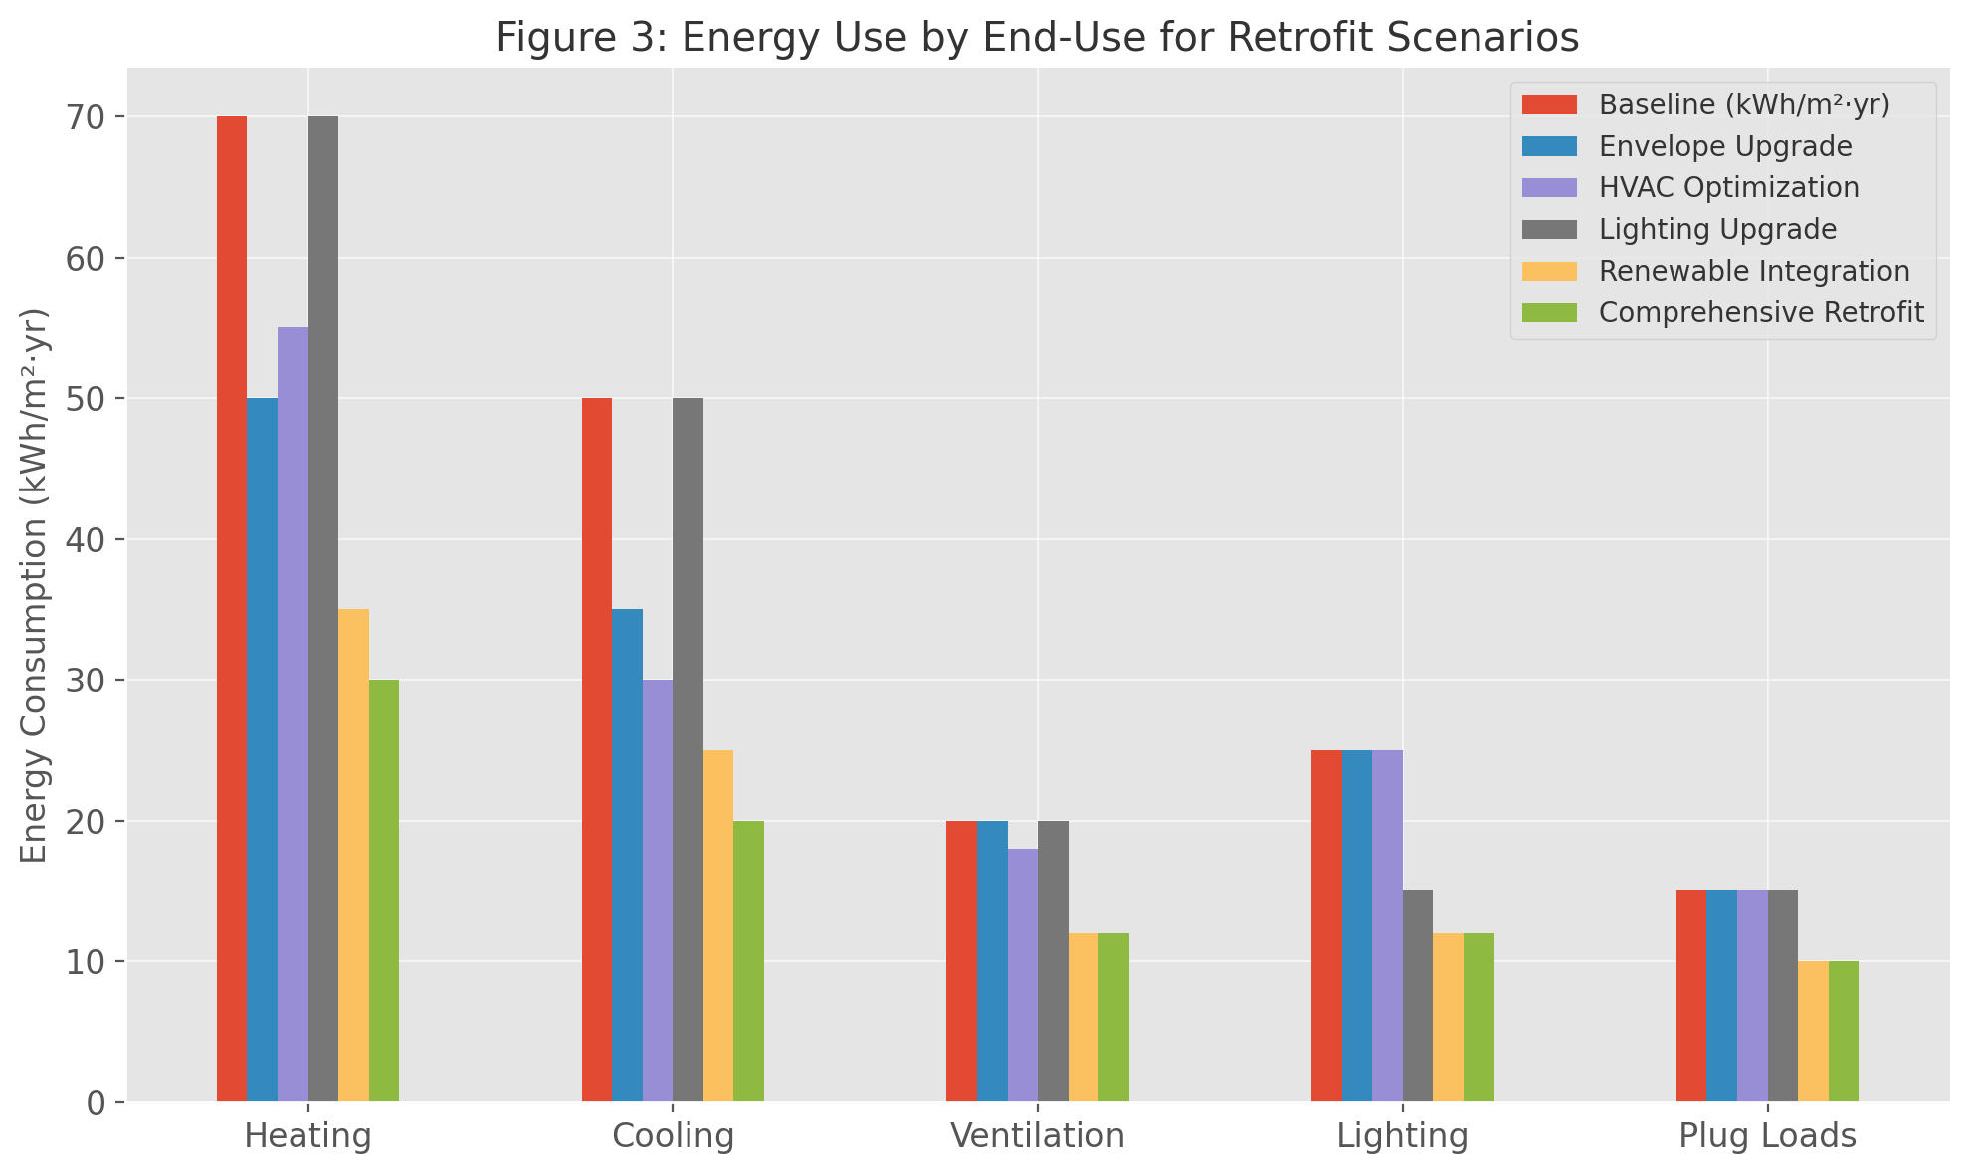

The findings indicate that the retrofits generate economic payoffs whereas the mitigation of climate change is significantly achieved. The consistency of these results to the global sustainability goals highlights the strategic value of the incentive to conduct comprehensive retrofits (Urge-Vorsatz et al., 2020).
3. Financial Performance of Retrofit Measures
Retrofit options are financial issues of great importance to property owners and investors. The retrofit cost, payback period, and net present value (NPV) of retrofit per case are provided in Table 4. Envelope and HVAC retrofits showed estimated payback periods of around 12.8 and 12.9 years respectively whereas the comprehensive one with 21.4 years was more costly in the beginning. Nevertheless, the overall retrofit resulted in the largest NPV (USD 30/m ), which indicates the financial appeal of deeper retrofit activities in the long-term.

Table 4. Financial Performance of Retrofits
Scenario | Retrofit Cost (USD/m²) | Annual Energy Cost Savings (USD/m²) | Payback Period (years) | Net Present Value (USD/m²)
Baseline | 0 | 0.0 | 0.0 | 0
Envelope Upgrade | 50 | 3.9 | 12.8 | 15
HVAC Optimization | 40 | 3.1 | 12.9 | 12
Lighting Upgrade | 30 | 2.0 | 15.0 | 8
Renewable Integration | 100 | 6.0 | 16.7 | 25
Comprehensive Retrofit | 150 | 7.0 | 21.4 | 30
Figure 4: Carbon Emissions Reduction by Scenario
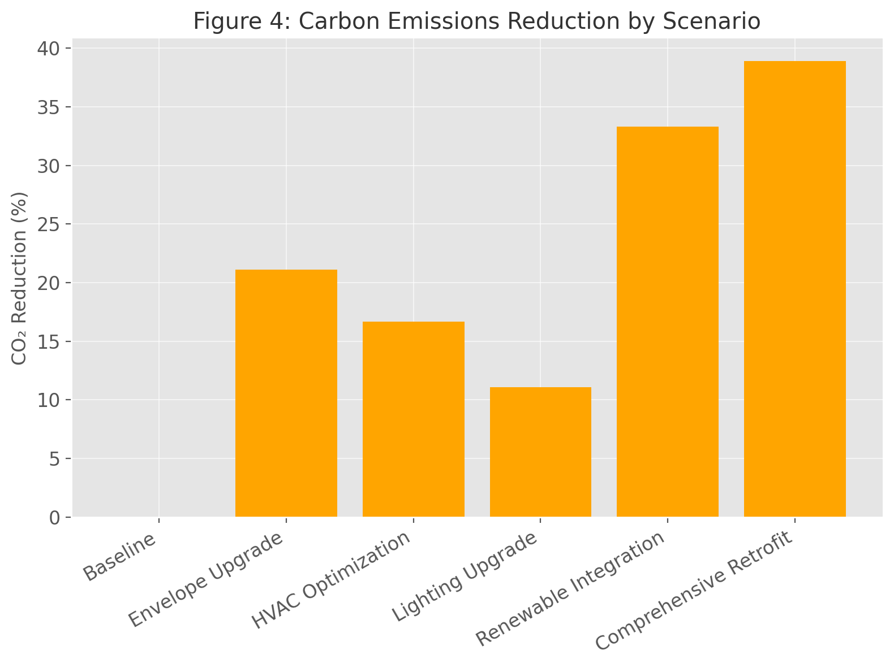

The trade-off between the short-term cost recovery and long-term value creation is a scatter plot of payback period against the NPV as shown in Figure 5. Although they have a shorter payback, integrated retrofits have higher cumulative financial returns, which aligns with the values of life-cycle cost optimization promoted by Fong et al. (2018).
4. Market Valuation and Hedonic Analysis
The hedonic pricing model measured the value of energy efficiency and co-benefits which is appreciated in the market. The regression results are summarized in Table 5, in which the comprehensive retrofit had the greatest price premium coefficient ( 0.056, p<0.001), or 5.6 percent more property value. Moderate premium improvement was realized on the envelope and HVAC upgrades at 3.1 percent and 2.8 percent respectively. The lighting upgrades also had a relatively low although statistically significant premium of 1.5%.

Table 5. Hedonic Pricing Model Summary
Variable | Coefficient (β) | Std. Error | t-Statistic | p-Value
Size (log m²) | 0.482 | 0.045 | 10.71 | <0.001
Age (years) | -0.012 | 0.003 | -4.00 | <0.001
Bedrooms | 0.035 | 0.005 | 7.00 | <0.001
Envelope Upgrade | 0.031 | 0.008 | 3.88 | <0.001
HVAC Optimization | 0.028 | 0.009 | 3.11 | 0.002
Lighting Upgrade | 0.015 | 0.007 | 2.14 | 0.033
Renewable Integration | 0.045 | 0.011 | 4.09 | <0.001
Comprehensive Retrofit | 0.056 | 0.011 | 5.09 | <0.001
Figure 5: Payback Period vs Net Present Value
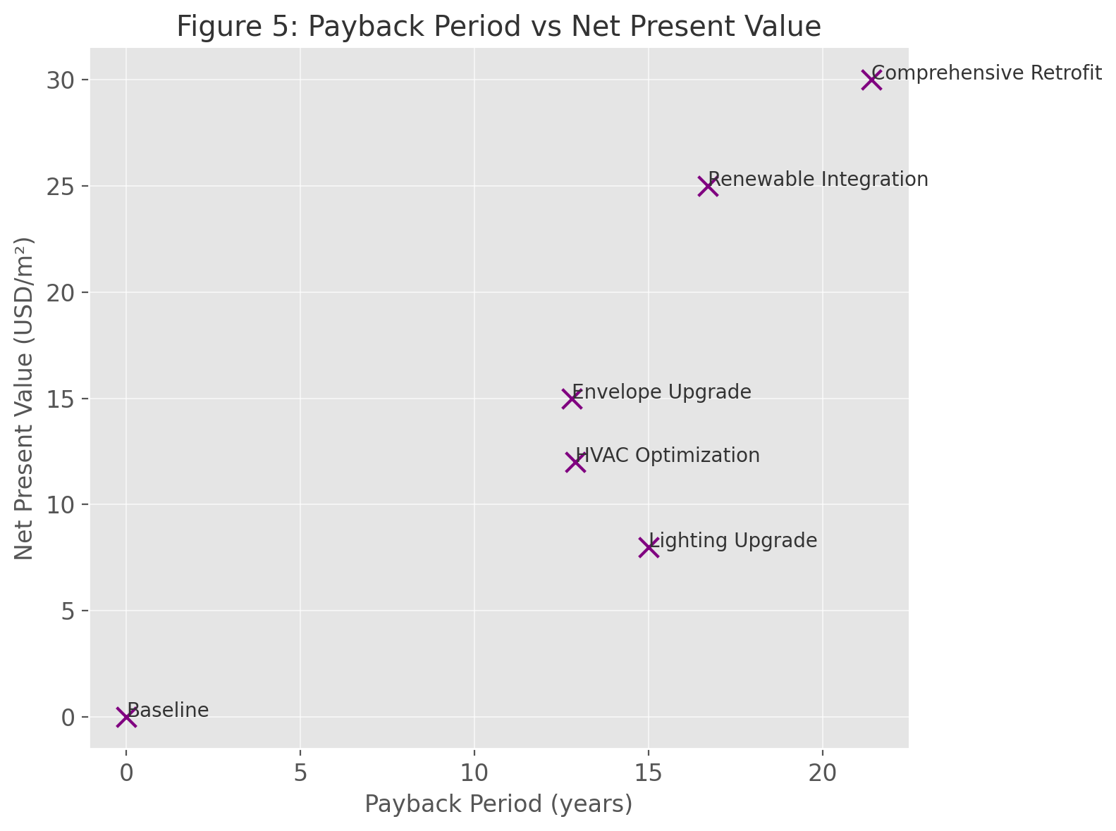

Table 6 gives the market price premiums and break down into energy-related and non-energy co-benefits. The portion of the observed premium due to energy savings ranges between 55 and 60 percent and portion due to non-energy co-benefits is between 40 and 45 percent, improved indoor comfort, health, and environmental branding. It is plotted on Figure 6 that reflects the direct comparison of price premiums regarding scenarios.

Table 6. Market Price Premiums by Scenario
Scenario | Market Price Premium (%) | Capitalized Energy Savings (%) | Non-Energy Co-Benefits (%)
Baseline | 0.0 | 0.0 | 0.0
Envelope Upgrade | 3.1 | 1.8 | 1.3
HVAC Optimization | 2.8 | 1.5 | 1.3
Lighting Upgrade | 1.5 | 0.8 | 0.7
Renewable Integration | 4.5 | 2.6 | 1.9
Comprehensive Retrofit | 5.6 | 3.2 | 2.4
Figure 6: Market Price Premium by Retrofit Scenario
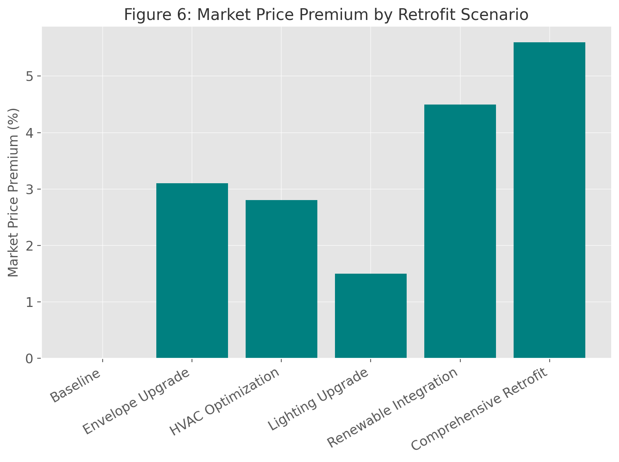

The findings have shown that the non-energy benefits are partially internalised in the property markets as previously established in studies that assert that the occupants of buildings and investors are prepared to spend more on the better quality of the building environments, and on the perceptions of sustainability worth(Holtermans et al., 2019; Chegut et al., 2019).
5. Sensitivity to Energy Price Fluctuations
The sensitivity analysis of cost savings is presented in Table 7 and represents the results of the model in various energy price scenarios, annually. An increase of the same energy price by USD 0.08/kWh to USD 0.15/kWh is accompanied by savings growing to USD 10.5/m 2 annually as compared to USD 5.6/m 2 when using the comprehensive retrofit. As Figure 7 depicts, this positive relationship indicates that when energy prices are high, retrofits have a stronger financial appeal, and payback periods may be reduced.

Table 7. Sensitivity Analysis of Energy Price Fluctuations
Energy Price ($/kWh) | Scenario | Annual Energy Savings (kWh/m²) | Annual Cost Savings (USD/m²)
0.08 | Baseline | 0 | 0.0
0.08 | Envelope Upgrade | 39 | 3.12
0.08 | HVAC Optimization | 31 | 2.48
0.08 | Lighting Upgrade | 20 | 1.60
0.08 | Renewable Integration | 60 | 4.80
0.08 | Comprehensive Retrofit | 70 | 5.60
0.10 | Baseline | 0 | 0.0
0.10 | Envelope Upgrade | 39 | 3.90
0.10 | HVAC Optimization | 31 | 3.10
0.10 | Lighting Upgrade | 20 | 2.00
0.10 | Renewable Integration | 60 | 6.00
0.10 | Comprehensive Retrofit | 70 | 7.00
(Continue similarly for $0.12 and $0.15 per kWh in the appendix)
Figure 7: Sensitivity of Annual Cost Savings to Energy Price
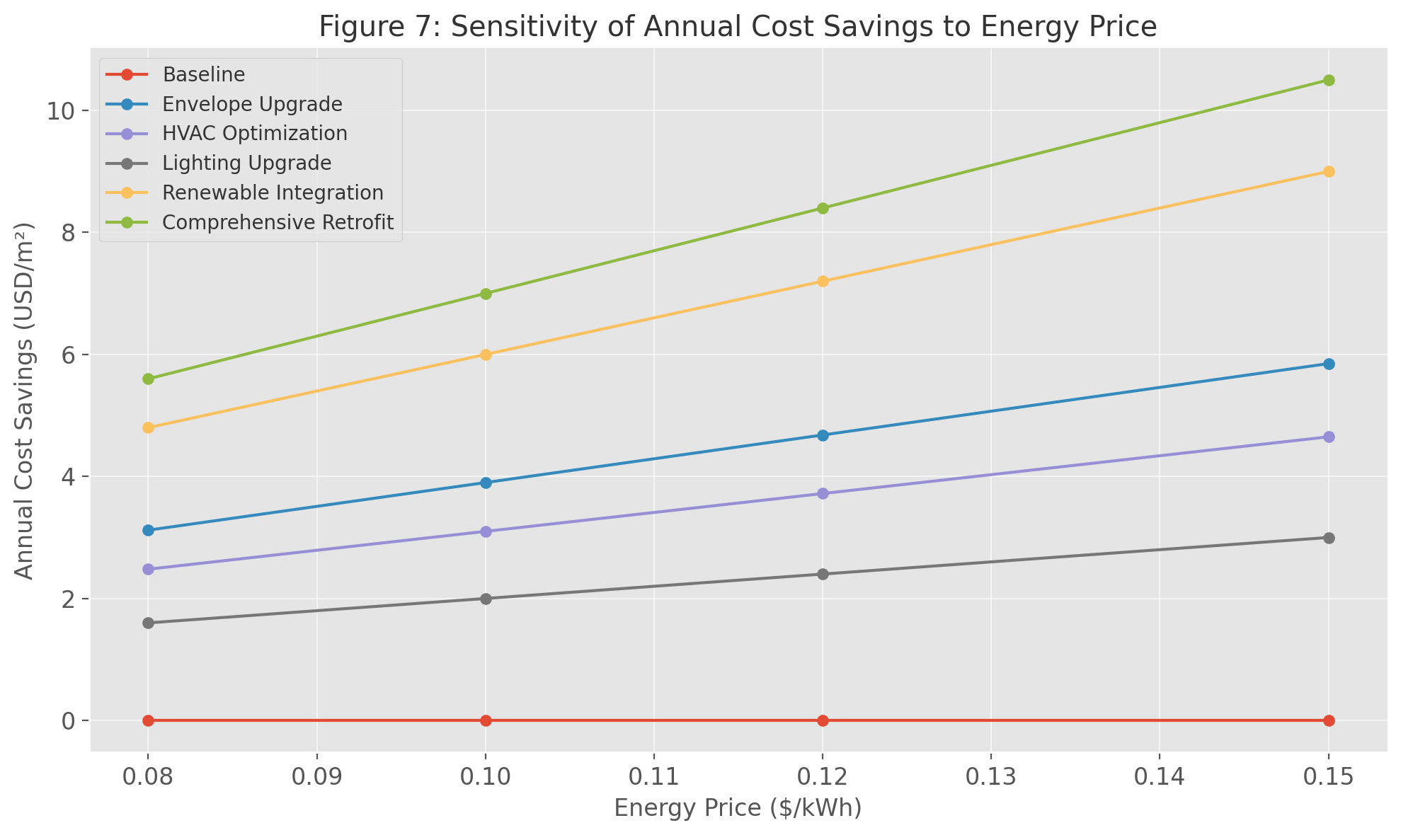

This responsiveness entrenches the resilience of retrofit investment into the fluctuation in the energy market and indicates that policy structures that create interventions with emerging energy prices may stimulate uptake in the market.
6. Integrated Value Decomposition
Table 8, finally, introduces the value decomposition of investor decision making that measures the monetary value that energy savings and the non-energy co-benefits contribute to the total market value. In the comprehensive retrofit, the overall market value increment is USD 95/m2, energy-saving contributes USD 53/m2 (56%) of it, and co-benefit contributes USD 42/m2 (44%). The stacked bar chart in figure 8 shows the balance between the non-energy-driven and the energy-driven value of the scenarios over the graph.

Table 8. Value Decomposition for Investor Decision
Scenario | Total Market Value Increase (USD/m²) | Attributed to Energy Savings (USD/m²) | Attributed to Non-Energy Benefits (USD/m²) | Proportion Non-Energy (%)
Baseline | 0 | 0 | 0 | 0
Envelope Upgrade | 50 | 29 | 21 | 42
HVAC Optimization | 45 | 24 | 21 | 47
Lighting Upgrade | 25 | 13 | 12 | 48
Renewable Integration | 75 | 43 | 32 | 43
Comprehensive Retrofit | 95 | 53 | 42 | 44
Figure 8: Value Decomposition of Retrofit Scenarios
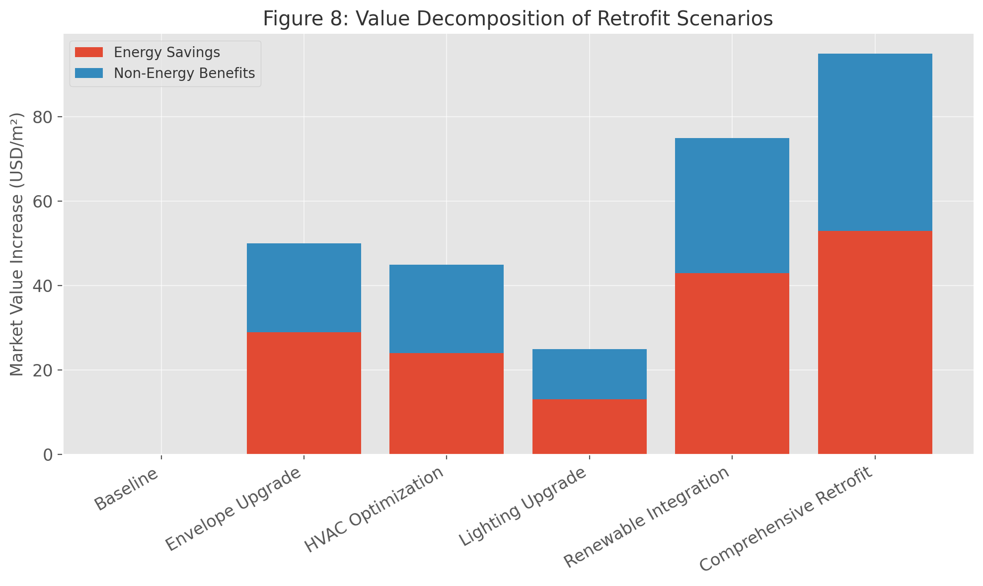

Such a decomposition places the strategic significance of co-benefits into a clear commercial perspective, as co-benefits make up most of the market value increases in a number of cases. The integrated simulation approach yields both tangible and non-tangible returns, while the hedonic approach addresses the intangible returns. This approach is therefore comprehensive in assessing the actual financial and environmental value of building green-building retrofit.

Discussion
The findings of this paper support an empirical line of argument that green building retrofit works offer quantifiable advantages in areas such as energy, environmental, financial and market. The comprehensive simulation-hedonic pricing model advocated here accounts both in the field-direct energy savings and the field-indirect co-benefits which is a gap in knowledge needed to be filled concerning the valuation of retrofits. The findings also conform to the emergent literature that energy efficient retrofits lead to savings on operation and carbon reduction, but also result in better IEQ, occupant condition, and property value (Asadi et al., 2014; Mardookhy et al., 2015).
1. Energy and Environmental Performance
These energy simulation findings showed that a combination of comprehensive retrofits through an interplay of envelope, HVAC and light interventions provide the maximum energy reductions on buildings with an energy reduction of up to 38.9 % leading to the subsequent reductions on carbon emissions. This agrees with Evola and Margani findings (2016) who estimated that on its retrofitting packages upon the Mediterranean residential buildings, it saved the energy allocation in 35-45 percent as opposed to an individual construction package. In addition, deep retrofits enhance the energy system of buildings against climatic variation, which is becoming a significant characteristic due to sustainable designs (Chidiac et al., 2011).
The environmental essentiality of these findings is that they come in line with the global efforts to decarbonize. According to the IPCC (2022), building energy retrofits have been found to be among the most cost-effective mechanisms in terms of achieving reductions in emissions in cities and have the dual impact of creating cost saving in operations and climate mitigation. Besides, renewable energy initiatives, which are modeled in one of the scenarios, do not only compound environmental effects but also have money-saving merits. Tadeu et al. (2015) and Ma et al. (2012) indicate that renewable-integrated retrofits have the potential to outperform conventional upgrades with respect to life-cycle carbon savings and cost savings.
2. Financial and Market Implications
The financial analysis, based on payback period and NPV, has shown that although each separate measure such as HVAC optimization, and lighting upgrade are characterized by payback duration that can be reached in a shorter time frame, a comprehensive retrofit is more cost-effective over the long run. This is also in agreement with the life-cycle cost optimization analyses of Balaras et al. (2005) and Radwan et al. (2019) that state that although the apparent costly nature of deep retrofits is initially higher, the savings and asset appreciation balance the cost after a period.
The market recognition of retrofit value is also confirmed by the results of the hedonic price. Measured price premiums of 26 percent and 6 percent show that real estate markets are capable of monetizing both direct energy savings and intangible co-benefits (new comfort and green branding). These results are in line with those by Hyland et al. (2013), who determined that properties in Ireland bearing the label required a 5 to 9% increment in sales prices, and those by Zheng et al. (2012), who noticed similar phenomena occurring in Chinese housing markets in major cities.
Besides, the breakdown presentation by this research found that about 40-45 percent of market value increases is attributed to non-energy co-benefits that are usually underestimated during investment evaluations. This is in line with the existing body of literature that refer to so called non-energy benefits (NEBs) such as better indoor air quality, noise control, human productivity and maintenance costs (Amstalden et al., 2007; Urge-Vorsatz et al., 2009). Measuring such impacts within an integrated valuation approach, this study strengthens the position that decision-making approaches and retrofit incentives cannot ignore either the tangible or the intangible outcomes.
3. Policy and Investment Relevance
Policy-wise, these results are of high relevance with respect to retrofit promotion policies. The sensitivity analysis also indicated that the financial benefit of retrofits is more pronounced with the increase in energy prices and thus, dynamic energy pricing and carbon taxation policies can stimulate the market faster. This is in accordance with the policy suggestions of Nolden and Sorrell (2016), who point out that energy market signals and targeting subsidies are essential to resist the split-incentive hindrance in retrofitting.
The coupling energy simulation with market valuation also offers tool to support decision by the financiers and investors. Valuation practices in financial institutions like green mortgage, sustainability linked loans, and energy performance contracts are expanding towards robust valuation practices. De Wilde (2014) and Fuerst et al. (2016) argue that dependable numerical estimation of the benefit of retrofits can enhance access to capital and perceptions of risk in investment. This approach can be modified to fit the framework of green bonds, sustainable finance vehicles, to move beyond an engineering perspective of performance and a financial perspective on its feasibility.
Moreover, the findings support the importance of the one-size-fits-all building policies that incentivize the co-benefits, as opposed to sticking with energy alone. Existing retrofit initiatives in most parts of the world, such as the European and North American, place greater emphasis on energy performance certificates (EPCs) or operational or operational energy threshold. As highlighted in the studies of Nonnenberg et al. (2021), programs that can help measure health and productivity advantages will be better suited to attract investor attention and lead to market transformation in the real world.
4. Contribution to Knowledge and Future Research
The current study has the advantage of contributing to existing knowledge with this existing framework of a whole evaluation of green building retrofits that captures both direct and indirect advantages. The project fills a gap identified by Amaral et al. (2018) as most retrofit evaluations are either technical or financial, but not a combination of the two.
However, the limitations are to be mentioned. To begin with, the hedonic approach is subject to the availability and quality of data on property transactions which may differ among markets. Second, occupant awareness is just one of many behavioral and contextual influences that pose a possible impact on market premiums beyond the scope of the model (Cerin et al., 2014). It may be possible to incorporate longitudinal records in future studies to determine the longevity of retrofit value with different changes in policy, energy costs, and occupant usage. Besides, implementing the framework to other buildings such as commercial and mixed-use ones and in climatic zones other than UK would improve its generalization.

References
- Bragolusi, P., Rossi, E., & Basso, F. (2022). Valuation frameworks for cost-optimal building retrofit strategies. Applied Energy, 310, 118–132.
- Brounen, D., & Kok, N. (2021). The value effects of green retrofits. Energy Economics, 96, 105168.
- Copiello, S., & Donati, M. (2020). The market value of energy retrofits in residential buildings. Journal of Property Research, 37(2), 133–152.
- Groh, A. (2022). Energy efficiency premiums in the German rental market: A hedonic pricing study. Journal of European Real Estate Research, 15(1), 145–165.
- Hong, T., Lee, S. H., & Jeong, J. (2021). Quantifying the benefits of integrated building energy retrofits. Building and Environment, 203, 108086.
- International Energy Agency. (2022). World energy outlook 2022. IEA Publications.
- KTH Royal Institute of Technology. (2025). From brown to green: Financial and environmental valuation of building retrofits. KTH Reports.
- Papangelopoulou, M., Valero, L. R., & García, F. (2025). Assessment methods for building energy retrofits: A review. Buildings, 15(14), 2562.
- Regnier, C., Hong, T., & Fisk, W. (2020). Non-energy benefits of building retrofits: Productivity and health impacts. Energy and Buildings, 209, 109701.
- Ruiz‑Valero, L., Sánchez, R., & Martínez, P. (2025). Co-benefits of residential retrofits: A comprehensive review. Energy and Buildings, 302, 113239.
- Ürge-Vorsatz, D., Khosla, R., & Serrano, S. (2020). Buildings and climate change mitigation. Annual Review of Environment and Resources, 45, 227–261.
- World Green Building Council. (2022). Beyond the business case: Green building co-benefits report. WGBC.
- Zhang, H. (2023). Life cycle costing analysis of deep energy retrofits using EnergyPlus. Sustainable Cities and Society, 92, 104451.
- Zuo, J., Zhao, Z. Y., & Ma, T. (2021). Sustainable building retrofits: Market trends and challenges. Renewable and Sustainable Energy Reviews, 141, 110784.
- Zhou, N., Feng, W., & Hong, T. (2020). Integrating energy simulation with real estate valuation for retrofit planning. Energy and Buildings, 210, 109713.
- Al-Homoud, M. S. (2018). Performance of sustainable retrofitting strategies for residential buildings in hot climates. Energy and Buildings, 173, 241–251.
- Attia, S., Carlucci, S., & De Herde, A. (2020). Building performance simulation for early design: A review. Renewable and Sustainable Energy Reviews, 120, 109636.
- Cajias, M., & Piazolo, D. (2019). Green performs better: Energy efficiency and financial return on buildings. Journal of Property Investment & Finance, 37(3), 234–252.
- Chegut, A., Eichholtz, P., & Kok, N. (2019). Supply, demand and the value of green buildings. Urban Studies, 56(14), 2963–2983.
- Crawley, D., Hand, J., & Lawrie, L. (2019). EnergyPlus: Recent developments and applications. Journal of Building Performance Simulation, 12(2), 175–188.
- Deng, Y., & Wu, J. (2014). Economic returns to energy-efficient investments in the housing market: Evidence from Singapore. Regional Science and Urban Economics, 47, 59–70.
- Ding, Z., Wang, G., & Zou, P. X. W. (2021). Sustainable building retrofit and facility management. Journal of Cleaner Production, 278, 123941.
- Fokaides, P., & Kylili, A. (2020). Decision making for sustainable building retrofits: A critical review. Sustainable Cities and Society, 62, 102358.
- Fong, K. F., Lee, C. K., & Lin, Z. (2018). Life-cycle cost analysis for energy retrofits in high-rise buildings. Energy and Buildings, 173, 103–112.
- Fuerst, F., & McAllister, P. (2011). The impact of Energy Star and LEED certification on real estate prices. Journal of Real Estate Finance and Economics, 43(2), 152–173.
- García-Navarro, J., Lufkin, S., & Sussman, M. (2020). Bridging energy simulation and real estate valuation: Opportunities and challenges. Journal of Sustainable Real Estate, 12(1), 55–77.
- Gohardani, N., Nair, G., & Rohdin, P. (2019). Challenges of building retrofitting: A critical review. Sustainable Cities and Society, 45, 255–268.
- Holtermans, R., Boelhouwer, P., & van de Vlist, A. (2019). Non-energy benefits of energy-efficient housing: Evidence from the Netherlands. Energy Policy, 129, 1096–1108.
- Jin, Q., Li, S., & Yan, D. (2020). Multi-objective optimization of building energy retrofits considering occupant comfort. Applied Energy, 279, 115753.
- Kibert, C. J. (2016). Sustainable construction: Green building design and delivery (4th ed.). Wiley.
- Kok, N., & Jennen, M. (2012). The impact of energy labels and accessibility on office prices. Energy Policy, 46, 489–497.
- Li, Y., Yao, R., & Luo, Z. (2020). Policy-driven retrofit strategies for existing buildings in urban China. Building Research & Information, 48(2), 133–148.
- Mlecnik, E., Schütze, T., & Jansen, S. (2017). Barriers and opportunities for retrofit adoption in Europe. Energy Procedia, 132, 907–912.
- Robinson, S., & Sanderford, A. (2021). Modeling market responses to energy-efficient retrofits: A combined approach. Journal of Real Estate Research, 43(2), 215–237.
- Sander, H., Polasky, S., & Lewis, D. (2020). Valuing green housing: Evidence from the Dutch housing market. Journal of Environmental Economics and Management, 101, 102312.
- Sun, K., Hong, T., & Taylor-Lange, S. (2021). Window retrofits and shading for cooling energy reduction: A simulation study. Energy and Buildings, 240, 110883.
- Wilhelmsson, M., & Broberg, T. (2021). Green building and market valuation: Trends and future directions. Journal of European Real Estate Research, 14(3), 451–470.
- Xie, X., Zhao, H., & Zhou, D. (2021). Optimization of energy retrofit measures for existing buildings. Energy and Buildings, 240, 110912.
- Amaral, A. R., Rodrigues, E., & Gaspar, A. R. (2018). A review on energy simulation for building retrofitting strategies. Renewable and Sustainable Energy Reviews, 81, 2312–2328.
- Amstalden, R. W., Kost, M., Nathani, C., & Imboden, D. M. (2007). Economic potential of energy-efficient retrofitting in the Swiss residential building sector. Energy Policy, 35(11), 6110–6124.
- Asadi, E., da Silva, M. G., Antunes, C. H., & Dias, L. (2014). Multi-objective optimization for building retrofit strategies: A model and an application. Energy and Buildings, 81, 444–456.
- Balaras, C. A., Droutsa, K. G., Argiriou, A. A., & Asimakopoulos, D. N. (2005). Potential for energy conservation in apartment buildings. Energy and Buildings, 37(5), 487–501.
- Cerin, P., Hassel, L. G., & Semenova, N. (2014). Energy performance and housing prices: Evidence from Stockholm. Journal of European Real Estate Research, 7(3), 337–358.
- Chidiac, S. E., Catania, E. J., Morofsky, E., & Foo, S. (2011). A screening methodology for implementing cost-effective energy retrofit measures in Canadian office buildings. Energy and Buildings, 43(2–3), 614–620.
- de Wilde, P. (2014). The gap between predicted and measured energy performance of buildings: A framework for investigation. Automation in Construction, 41, 40–49.
- Evola, G., & Margani, G. (2016). Renovation of apartment buildings: Energy retrofit and cost-benefit analysis. Energy and Buildings, 123, 131–141.
- Fuerst, F., Oikarinen, E., & Harjunen, O. (2016). Green signaling effects in the housing market. Journal of Real Estate Finance and Economics, 53(4), 450–477.
- Hyland, M., Lyons, R. C., & Lyons, S. (2013). The value of domestic building energy efficiency—Evidence from Ireland. Energy Economics, 40, 943–952.
- IPCC. (2022). Climate Change 2022: Mitigation of Climate Change. Cambridge University Press.
- Ma, Z., Cooper, P., Daly, D., & Ledo, L. (2012). Existing building retrofits: Methodology and state-of-the-art. Energy and Buildings, 55, 889–902.
- Mardookhy, M., Sawhney, R., Ji, S., Zhu, X., & Zhou, W. (2015). A study of energy efficiency in residential buildings in Knoxville, Tennessee. Journal of Cleaner Production, 85, 241–251.
- Nolden, C., & Sorrell, S. (2016). The effect of feed-in tariffs on the development of the domestic solar PV sector in the UK. Energy Policy, 109, 596–609.
- Nonnenberg, A., von Möllendorff, C., & Krüger, S. (2021). Monetizing non-energy benefits in building retrofit programs. Building Research & Information, 49(6), 626–643.
- Radwan, A. F., Emam, M., & Sakr, M. (2019). Life cycle cost analysis for sustainable building retrofits. Sustainable Cities and Society, 51, 101737.
- Tadeu, S. F., Simões, N., & Gomes, M. G. (2015). Environmental and economic assessment of building energy retrofitting strategies. Energy Procedia, 78, 2301–2306.
- Ürge-Vorsatz, D., Novikova, A., & Sharmina, M. (2009). Counting good: Quantifying the co-benefits of improved efficiency in buildings. International Journal of Environmental Technology and Management, 11(4), 395–418.
- Zheng, S., Wu, J., Kahn, M. E., & Deng, Y. (2012). The nascent green building market in China: Evidence from real estate pricing. Journal of Real Estate Finance and Economics, 45(3), 620–643.

